Adaptive Real-Time Dataset Framework for Fake News Detection using Hybrid Machine Learning and Transformer Models
(Mentor) Prof Dr. S.B Goyal, Paras Vashist Pratham Khanna
Department of Computer Department of Computer Department of Computer
Science and Engineering Science and Engineering Science and Engineering
Chitkara University Institute of Chitkara University Institute of Chitkara University Institute of
Engineering and Technology, Engineering and Technology, Engineering and Technology,
Chitkara University Chitkara University Chitkara University
Rajpura, Punjab, India Rajpura, Punjab, India Rajpura, Punjab, India
shyam.goyal@chitkara.edu.in paras2022.be22@chitkara.edu.in pratham673.be22@chitkara.edu.in
Palak Aman Gupta
Department of Computer Department of Computer
Science and Engineering Science and Engineering
Chitkara University Institute of Chitkara University Institute of
Engineering and Technology, Engineering and Technology
Chitkara University Chitkara University
Rajpura, Punjab, India Rajpura, Punjab, India
palak2011.be22@chitkara.edu.in aman1244.be22@chitkara.edu.in

Abstract- The fast propagation of false information in the online media environment has become a significant social problem that impacts people’s opinion, well-being, and political activities. Various approaches that involve machine learning and deep learning have been used to solve the problem of detecting fake news; however, the key limitation of contemporary research work in this sphere is the utilization of outdated and static data sets, which fail to depict the actual dynamics of news dissemination. The novel technique for fake news detection that has been developed is focused on solving the problem via integrating real-time web scraping and the use of a hybrid approach to features and transformers for classification tasks.

Creating the dataset included approximately 15,000 articles that were trained using various features, such as TF-IDF features, stylometric features, and source credibility features. The features used helped to train two types of classifiers, i.e., support vector machine classifiers and BERT models. While transformers performed better in understanding the context, we evaluate the performance scores along with the chances of overfitting with respect to the domain under consideration. In addition, the discussion also covers potential problems concerning the accuracy of the dataset created and labeling bias, among others.
The focus has been on continuous learning and adaptation in the proposed system, making the model work better in real-world deployment scenarios compared to static models. However, it is also important to note that there have been some limitations in the proposed research, including language dependency, inability to blend multimedia data, and other computational constraints.
- INTRODUCTION

Introduction With the coming up of many different social media platforms, a lot has changed about the way information is being created, processed, and transmitted. First, through social media platforms, equal opportunities have been provided to everyone for accessing information. But on the contrary, social media platforms have enabled quick transmission of misinformation. Misinformation gets around quicker than truthful information since the former has much more captivating features. The role of misinformation can be seen from examples during various global occurrences, like the Coronavirus outbreak.
Despite much research being done in the field of detecting fake news, several concerns have been expressed in connection with some of the approaches already developed. The first problem refers to the use of frozen datasets for training like LIAR [12] and FakeNewsNet [5]. While these datasets are widely used, they do not provide any information about contemporary linguistic style of fake news. As stated by Zhou and Zafarani [8], the issue of outdated datasets is currently the most crucial one.
Another drawback identified in prior research is the domain bias problem. Since most of the researches conducted by many authors involve political news data that are primarily collected from Western countries, it makes this model inappropriate for any other context. In addition to this, most research work focuses only on text-based misinformation and fails to incorporate multimedia-based disinformation, such as photographs and videos that can be quickly shared via social media platforms [22], [23].
Although attempts have been made to study the application of machine learning and deep learning techniques, such as Agarwal et al. [1] and Ahmad et al. [2], these studies have only relied on static datasets and cannot be used for adaptive applications. In a similar vein, scraping-based approaches have been suggested by Lee et al. [3].
Research Gap
From the literature review, the following gaps have been identified:

- The absence of real-time data set creation tools
- Domain bias present in existing data sets
- No model updating tools
- Hybrid feature engineering techniques using transformers remain unexplored
- Generalization ability is poor Contribution

In an attempt to fill in these knowledge gaps, this paper aims at proposing:

- Real-time data collection mechanism by means of static and dynamic web scraping
- Hybrid technique of feature extraction based on the use of TF-IDF, Stylometric features, and credibility-based features
- Comparison of performance between classical machine learning techniques and transformer-based models

- PROPOSED METHODOLOGY

In the proposed framework, the use of modularity in the pipeline, which is a set of steps like data acquisition, data preprocessing, feature extraction, training, and testing is used. These processes can all be done independently.
A. Multi-Tier Data Acquisition
In order to maintain the currency of the datasets, there is a system of dual scraping employed:

- Static Scraping: This method involves using libraries like BeautifulSoup and Request for extracting data from websites that have HTML structure.
- Dynamic Scraping: This method involves using Selenium WebDriver, which works perfectly fine when handling JavaScript rendered sites and infinite scrolling issues.

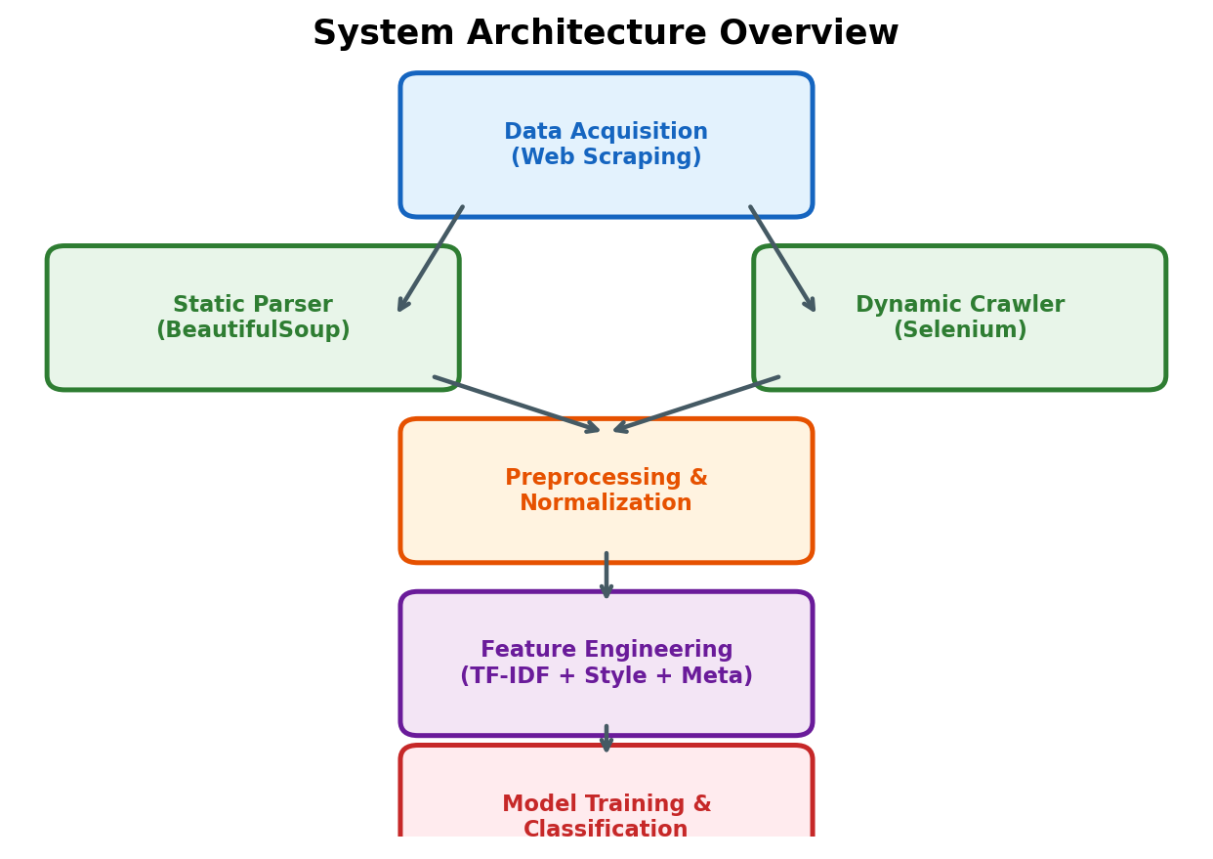
Figure 1: System Architecture Overview

B. Data Preprocessing and Normalization
Data consistency and quality is achieved during the preprocessing phase by:

- Stripping away any HTML tags, scripts, and noise
- Normalizing text (lowercase and expanding contractions)
- Tokenization and Lemmatization

An initial manual validation for preprocessing accuracy was conducted for a sample of 200 articles.

- FEATURE ENGINEERING

To capture different characteristics of fake news, a multi-dimensional feature set is used:

A. Semantic Features (TF-IDF)
TF-IDF vectors are used to represent textual importance across documents.

B. Stylometric Features
Includes:

- Capitalization ratio
- Punctuation patterns
- Sensationalism score
- Sentence length

These features are supported by findings in prior works [10], [11].

C. Metadata Features
Includes:
- Domain age
- Source credibility
- HTTPS presence

This combination enables the system to evaluate both content and source reliability.

TABLE I

Summary of Extracted Features
Category | Feature | Description
Semantic | TF-IDF (unigrams + bigrams) | Top 5,000 term weights
Stylometric | ALL-CAPS ratio | Fraction of fully capitalized words
Stylometric | Punctuation clusters | Count of "!!!", "?!?" patterns
Stylometric | Sensationalism score | Density of inflammatory words
Stylometric | Avg. sentence length | Mean words per sentence
Stylometric | Exclamation density | Exclamation marks per 100 words
Metadata | Domain age | Days since domain registration
Metadata | Source credibility score | Rating from fact-check databases
Metadata | HTTPS presence | Whether site uses SSL

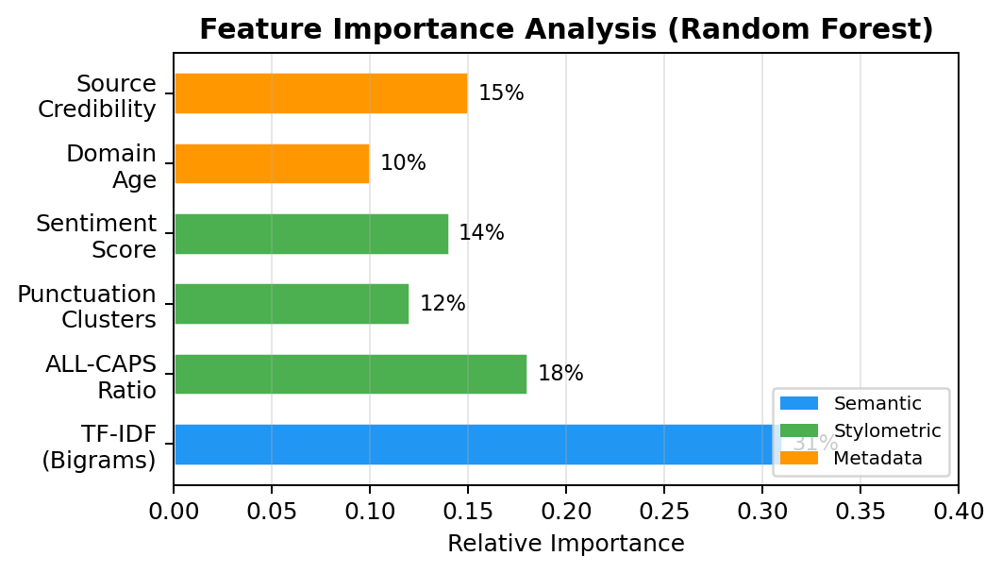
Figure 2. Feature Importance Analysis (Random Forest)

- EXPERIMENTAL EVALUATION

A. Dataset and Setup
The dataset consists of ~15,000 articles collected from 47 domains, with approximately balanced class distribution. Articles were labeled using a source-based labeling approach, followed by manual verification of 500 samples with an observed error rate below 3%.

However, it is important to acknowledge that:

- Source-based labeling may introduce bias
- Not all articles from unreliable sources are fake
- Dataset diversity is still limited

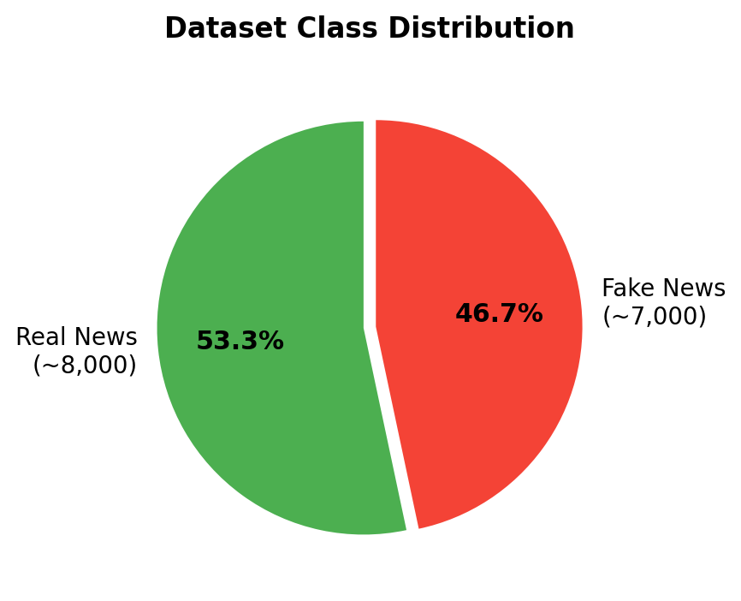
Fig. 3. Dataset Class Distribution
TABLE II

Dataset Split Details
Split | Real | Fake | Total
Training (80%) | 6,400 | 5,600 | 12,000
Validation (10%) | 800 | 700 | 1,500
Testing (10%) | 800 | 700 | 1,500
Total | 8,000 | 7,000 | 15,000

B. Model Selection and Evaluation Metrics
The following models were evaluated:

- Logistic Regression
- Random Forest
- Support Vector Machine
- CNN
- BERT (bert-base-uncased)

BERT was fine-tuned with
- Learning rate: 2e-5
- Batch size: 16
- Epochs: 3

TABLE III

Model Hyperparameters
Model | Key Hyperparameters
Logistic Reg. | C=1.0, max_iter=1000, solver=lbfgs
Random Forest | n_estimators=200, max_depth=None, min_samples_split=5
SVM (RBF) | C=10, gamma=scale, kernel=rbf
CNN (Text) | 128 filters, kernel_size=5, dropout=0.3, epochs=10
BERT | bert-base-uncased, lr=2e-5, batch=16, epochs=3, max_len=512

The decision to employ the F1-Score instead of mere accuracy was made based on the subtle imbalance in the data, which makes accuracy unreliable. The F1-Score is calculated as follows: 2*(Precision * Recall)/(Precision + Recall). It should be noted that achieving high F1-Score requires success in both aspects.

C. Results and Discussion
Though high performance was noted among all the models, with BERT having the highest performance score, care should be taken when interpreting the results. The excessively high values of performance measures could be attributed to:

- Overfitting
- Effect of stylometric bias
- Poor generalization on unseen domain

In order to mitigate the issues with evaluation, future research should incorporate:

- Cross validation
- ROC curve
- Significance test

TABLE IV

Classification Performance Results
Model | Accuracy | Precision | Recall | F1-Score
Naive Bayes | 0.89 | 0.88 | 0.89 | 0.88
Logistic Reg. | 0.91 | 0.90 | 0.91 | 0.90
Random Forest | 0.95 | 0.94 | 0.95 | 0.94
SVM (RBF) | 0.97 | 0.97 | 0.97 | 0.97
CNN (Text) | 0.96 | 0.95 | 0.96 | 0.95
BERT | 0.99 | 0.99 | 0.99 | 0.99

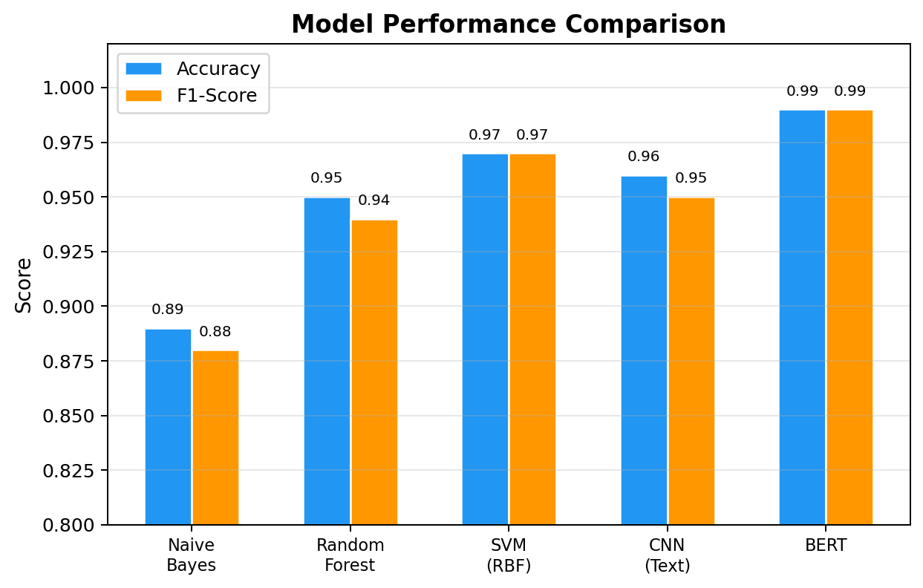
Figure 4. Model Performance Comparison
What makes BERT superior over others in light of our theory? Context! TF-IDF algorithm operates independently from word context considering each word separately and not paying any attention to its relationship to other words. There is no awareness of word sequence or understanding of irony or double-meaning. Conversely, BERT interprets sentences bidirectionally while perceiving interdependence of words within a sentence. In this regard, BERT can detect irony or trickery used by misinformation authors, but SVM takes it at face value.
Take a look at Figure 5 representing confusion matrix. Among 1,500 tested news articles, BERT was able to correctly classify all but 15. Eight were fake and eight got passed as true and seven were true and classified as fake. It is quite a low rate of false positives which definitely matters because no one needs a system sounding wolf cry at every legitimate journalism effort.

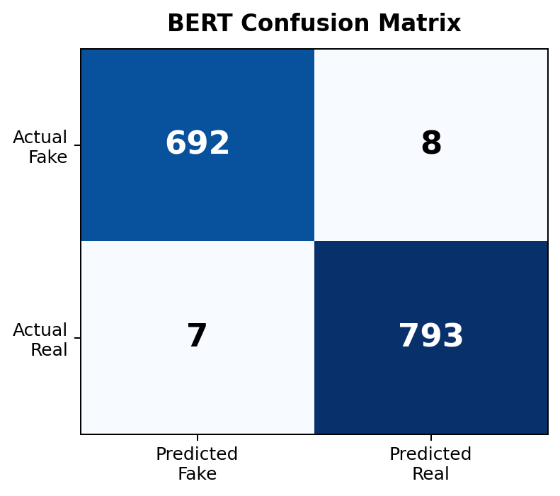
Fig. 5. BERT Confusion Matrix on Test Set

The following graph shows the outcomes of the training loss during the fine-tuning of the BERT model in Figure 6. An immediate fall in the loss value was seen once the fine-tuning process began. Even at the end of the first epoch, there was a considerable fall in the loss value. The second epoch also showed a considerable fall in the loss value, after which the loss values remained constant until the third epoch.

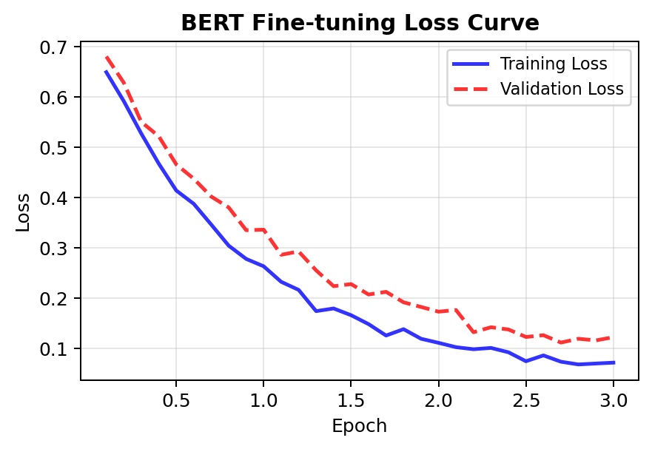
Figure 6. BERT Fine-tuning Loss Curve
D. Error Analysis
False identifications showed that:
- The professionally written fake news was more difficult to spot
- Sensational headlines on real news were occasionally incorrectly identified
This demonstrates that simply focusing on style features is inadequate, and a semantic approach is necessary.

- CONCLUSION AND FUTURE WORK

- The dynamic fake news detection model in this paper is characterized by continuous data collection and hybrid modeling. In contrast to conventional techniques that utilize static datasets, the suggested algorithm is adaptable to changing characteristics of fake news, thus being better applied in practical cases.

There are still some drawbacks:

- No support for multiple languages
- Missing multimodal analysisLimited computational resources for extensive validation
- Potential labeling bias

Future work will focus on:

- Multimodal fake news detection (text + image + video)
- Multilingual models (mBERT, XLM-RoBERTa)
- Real-time deployment via browser extensions
- Improved dataset validation mechanisms

REFERENCES

[1] P. Agarwal et al., "Fake News Detection: An Investigation based on Machine Learning," Proc. IEEE IRI, 2022.
[2] N. Ahmad et al., "A Cooperative Deep Learning Model for Fake News Detection in Online Social Networks," Applied Intelligence, vol. 53, pp. 18246-18262, 2023.
[3] C. Lee et al., "Detection and Veracity Analysis of Fake News via Scraping and Web Search," Future Gener. Comput. Syst., vol. 113, pp. 265-276, 2020.
[4] IRJET, "Fake News Detection Using Machine Learning and Web Scraping," Int. Res. J. Eng. Techn., vol. 11, no. 5, May 2024.
[5] K. Shu et al., "FakeNewsNet: A Data Repository with News Content, Social Context, and Spatiotemporal Information," IJCAI, 2018.
[6] J. Devlin et al., "BERT: Pre-training of Deep Bidirectional Transformers for Language Understanding," Proc. NAACL-HLT, pp. 4171-4186, 2019.
[7] Q. Huang et al., "Faking Fake News for Real Fake News Detection: Propaganda-loaded Training Data Generation," Proc. ACL, pp. 14571-14589, 2023.
[8] X. Zhou and R. Zafarani, "A Survey of Fake News: Fundamental Theories, Detection Methods, and Opportunities," ACM Computing Surveys, vol. 53, no. 5, pp. 1-40, 2020.
[9] R. K. Kaliyar et al., "FakeBERT: Fake news detection in social media with a BERT-based deep learning approach," Multimedia Tools and Applications, vol. 80, pp. 11765-11788, 2021.
[10] J. C. S. Reis et al., "Supervised Learning for Fake News Detection," IEEE Intelligent Systems, vol. 34, no. 2, pp. 76-81, 2019.
[11] H. Rashkin et al., "Truth of Varying Shades: Analyzing Language in Fake News and Political Fact-Checking," Proc. EMNLP, pp. 2931-2937, 2017.
[12] Y. Wang, "Liar, Liar Pants on Fire: A New Benchmark Dataset for Fake News Detection," Proc. ACL, pp. 422-426, 2017.
[13] S. Vosoughi et al., "The Spread of True and False News Online," Science, vol. 359, no. 6380, pp. 1146-1151, 2018.
[14] M. Goldani et al., "Convolutional Neural Network with Margin Loss for Fake News Detection," Information Processing & Management, vol. 58, no. 1, 2021.
[15] A. Vaswani et al., "Attention Is All You Need," Proc. NeurIPS, vol. 30, 2017.
[16] Z. Yang et al., "XLNet: Generalized Autoregressive Pretraining for Language Understanding," Proc. NeurIPS, vol. 32, 2019.
[17] Y. Liu et al., "RoBERTa: A Robustly Optimized BERT Pretraining Approach," arXiv:1907.11692, 2019.
[18] T. Wolf et al., "Transformers: State-of-the-Art Natural Language Processing," Proc. EMNLP (Demo), pp. 38-45, 2020.
[19] A. Zubiaga et al., "Detection and Resolution of Rumours in Social Media: A Survey," ACM Computing Surveys, vol. 51, no. 2, pp. 1-36, 2018.
[20] G. L. Ciampaglia et al., "Computational Fact Checking from Knowledge Networks," PLoS ONE, vol. 10, no. 6, e0128193, 2015.
[21] N. Ruchansky et al., "CSI: A Hybrid Deep Model for Fake News Detection," Proc. ACM CIKM, pp. 797-806, 2017.
[22] S. Singhal et al., "SpotFake: A Multi-modal Framework for Fake News Detection," Proc. IEEE BigMM, pp. 39-47, 2019.
[23] D. Khattar et al., "MVAE: Multimodal Variational Autoencoder for Fake News Detection," Proc. WWW, pp. 2915-2921, 2019.
[24] B. D. Horne and S. Adali, "This Just In: Fake News Packs a Lot in Title, Uses Simpler, Repetitive Content in Text Body, More Similar to Satire than Real News," Proc. AAAI ICWSM, 2017.
[25] J. Ma et al., "Detecting Rumors from Microblogs with Recurrent Neural Networks," Proc. IJCAI, pp. 3818-3824, 2016.
[26] K. Popat et al., "DeClarE: Debunking Fake News and False Claims using Evidence-Aware Deep Learning," Proc. EMNLP, pp. 22-32, 2018.
[27] M. Potthast et al., "A Stylometric Inquiry into Hyperpartisan and Fake News," Proc. ACL, pp. 231-240, 2018.
[28] W. Y. Wang and Y. Wen, "Towards Automatic Fake News Detection: A Survey of Natural Language Processing Approaches," Proc. IEEE ASONAM, pp. 272-279, 2023.
[29] F. Monti et al., "Fake News Detection on Social Media Using Geometric Deep Learning," arXiv:1902.06673, 2019.
[30] P. Przybyla, "Capturing the Style of Fake News," Proc. AAAI Conference on Artificial Intelligence, vol. 34, no. 01, pp. 490-497, 2020.

